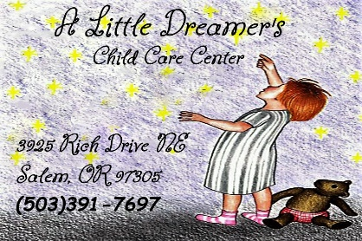
Permissions

PHOTOS/VIDEO:
A Little Dreamer’s Child Care Center may use my child’s picture for the Parent Portal, promotion, advertising, website, brochure, etc. strictly under A Little Dreamer’s Child Care Center LLC.

PLEASE CIRCLE ONE:

I ACCEPT I DECLINE

SUNBLOCK:
I give A Little Dreamer’s Child Care Center LLC and their staff permission to administer sunblock to my child as needed.

PLEASE CIRCLE ONE:

I ACCEPT I DECLINE

PARENT/GUARDIAN SIGNATURE:________________________________

