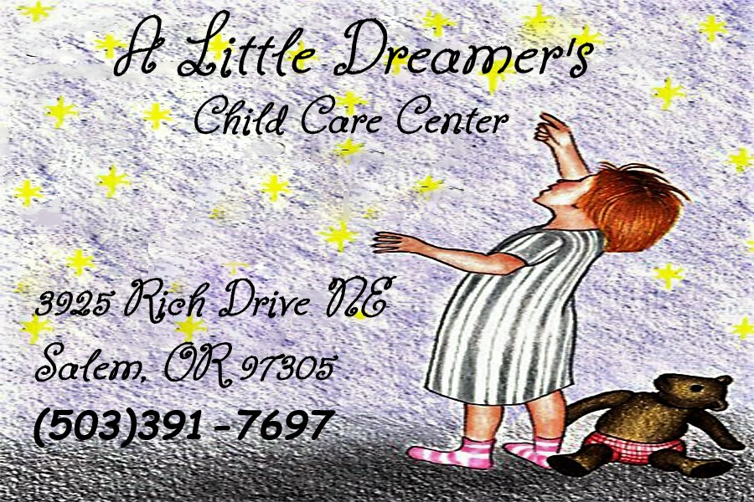ALL ABOUT ME

Child’s Name: ________________________ _Nickname: __________________________

I have ____ Brothers & ____ Sisters, their names and ages are: _______________ __

_______________________________________________________________________ __

How would you describe your child’s personality? _____________________________ _

_____________________________________________________ __

Has your child been in child care before? ( ) Yes ( ) No If yes, please give last childcare provider’s information:

Name: _____________________________________ Phone: ( ) ____________

Dates attended: from _____ to ______ Why was care terminated? _________________

_________________________________________________________________________

May I contact them for a reference? ( ) Yes ( ) No

Does your child have a regular bedtime schedule? ( ) Yes ( ) No

What time does your child usually go to bed at night? __________

What time does your child usually wake up in the morning? ___________

Does your child have trouble sleeping? ______ Night Terrors? ____ Trouble going to sleep? _____ Other:

____________________________________________________________________ _

Are there any special dolls, blankets, etc. that your child needs to go to sleep?

___________________________________________________________________

What is your child’s disposition upon waking up? (happy, grouchy, clingy, slow)

_____________________________________________________________________

Has or does your child have any known health problems? ( ) Yes ( ) No

If yes, describe: ______________________________________________________________

Does your child need regular medication? ( ) Yes ( ) No

If Yes, when is it given? ______________________________________________________________

Does your child have any known allergies? ( ) Yes ( ) No

If Yes, please list: ____________________________________________________________ _

Special instructions in case of an allergic reaction: ___________________________

______________________________________________________________________

Has your child had any of the following communicable diseases? (chicken pox, measles, mumps, other)

__________________________________________________

Is your child prone to upset stomach, colds, seasonal allergies, earaches, headaches, sore throats, nose bleeds, other?

Are there any indications of hearing or vision problems? ______________________

Has your child had any recent illnesses? ( ) Yes ( ) No

If Yes, please describe: _______________________________________________________________________

Does your child have any physical or mental disabilities? ( ) Yes ( ) No

If Yes, please explain: __________________________________________________________

Do you have a back-up plan if your child is ill and cannot attend or becomes ill and must be picked up? ( ) Yes ( ) No

What are your child’s eating habits? (mind trying new things, times usually eats, etc.)

_______________________________________________________

If your child is an infant, what kind of formula does your child drink? ______________________

Please describe Child’s usual dining habits (high chair, booster seat, feeds self, uses utensils, bottle, sipper cup)

_________________________

Does your child eat unaided? ________ Does he/she enjoy eating? ________

Does your child have a special diet? ________

Any foods that should NOT be served to your Child? ( ) Yes ( ) No

Please list these foods: ______________________________________________

Favorite foods: _____________________________________________________

Strong dislikes: _____________________________________________________

Will your child usually eat breakfast here or at home? ______________________

Please explain what are your expectations of this program? ______________________________________________________________________________________________________________________________________________________________________________________________

